**Control Award**

**Robo – Phantoms #23954**

**Autonomous Objectives**

We will preload 1 yellow and purple pixel. Our autonomous will detect which spike marker tape the team prop is on using a touch. Based on what spike marker tape the team prop is on, the robot will push the team prop out of the way and drop the purple pixel on the spike marker tape. After that, the robot will put the yellow pixel on the backdrop and park.

**Sensors**

* Distance Sensor
* We thought of using a gyro and imu to make sure the robot was positioned correctly.
* We thought of using a webcam and checking the color saturation, but we did not have the time and materials needed.
* Touch Sensor
* Color sensor for the line following algorithm (not needed)
* Gyro Sensor was explored

**Key Algorithms**

Currently to stop the arm from going too high, we are using an arm encoder, but only in the autonomous program. In the driver-control period, we will use a PIDF loop, because zip – ties can get stuck on the robot and not let the arm go up. We were also going to use line following, but we didn’t use it because the spike marker tapes were too small. Line following algorithm was thought of but did not find the need for it.

**Driver Controlled Enhancements**

To move the arm up at a specific angle, we are using a PIDF loop. When we press the “x” button on gamepad, the arm goes to the target position, making it easier to keep the arm up. In the chassis driver controls, we also added moving buttons that move the robot in small increments. This helps us be more accurate when in front of the backdrop and going through the truss.

**Engineering Portfolio References**

To find Our team’s information, check section 1 – 3 in the engineering notebook. To find information about our improvements go to sections 4-6 and 10-12.

**Autonomous Diagram**

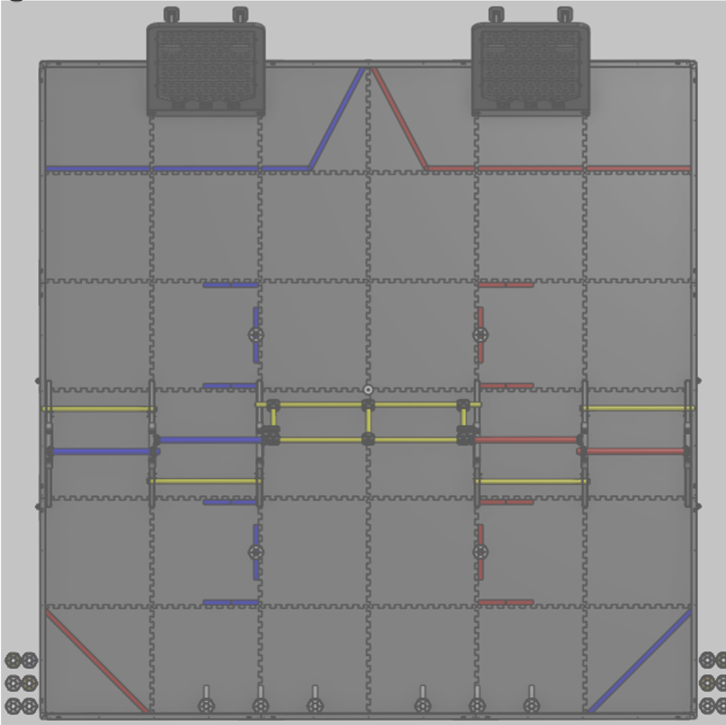

**Calibration Path**

**Robot Path to drop Pixel at the Spike Mark, Backdrop**

**Robot Parking Location**